**Assignment 1** :- Create an IAM user with username of your own wish and grant

administrator policy.

Created iron-man user and assigned administrator policy

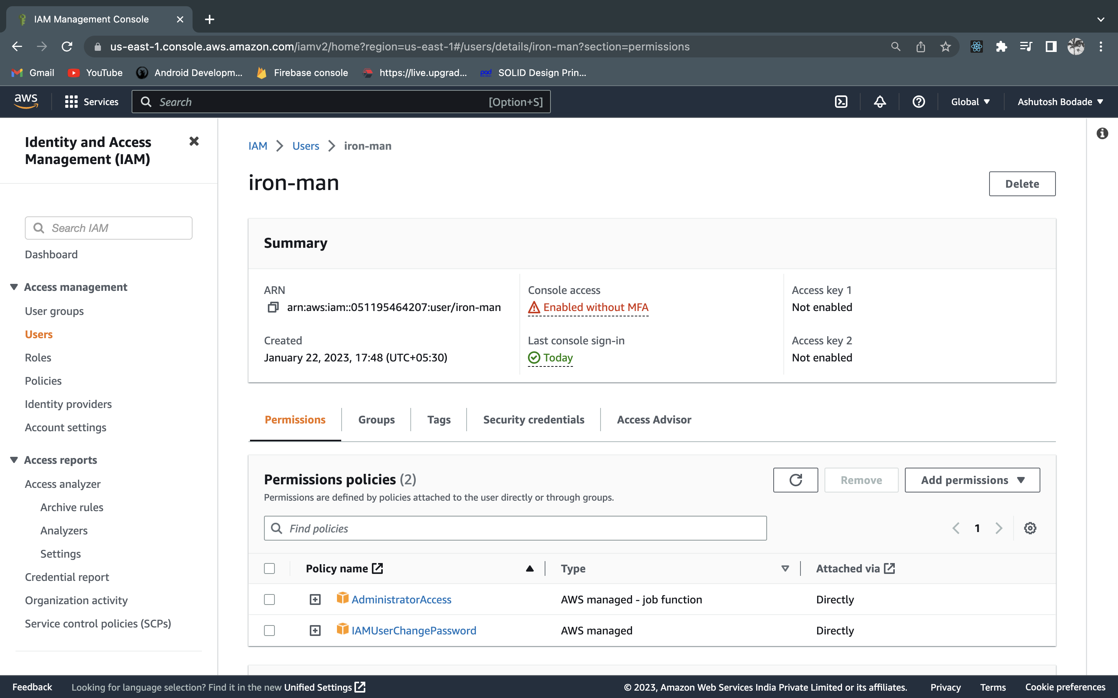

**Assignment 2** :- Hello students, in this assignment you need to prepare a

developers team of avengers.

- Create 3 IAM users of avengers and assign them in developer’s groups with

IAM policy.

Created users hulk, iron-man, thor

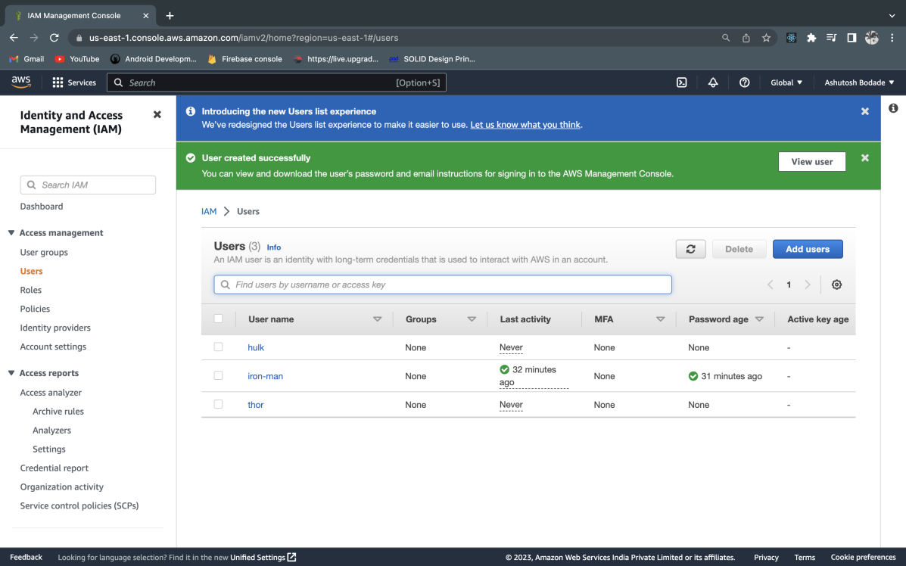

Created avenger group of user and assgned three users to it

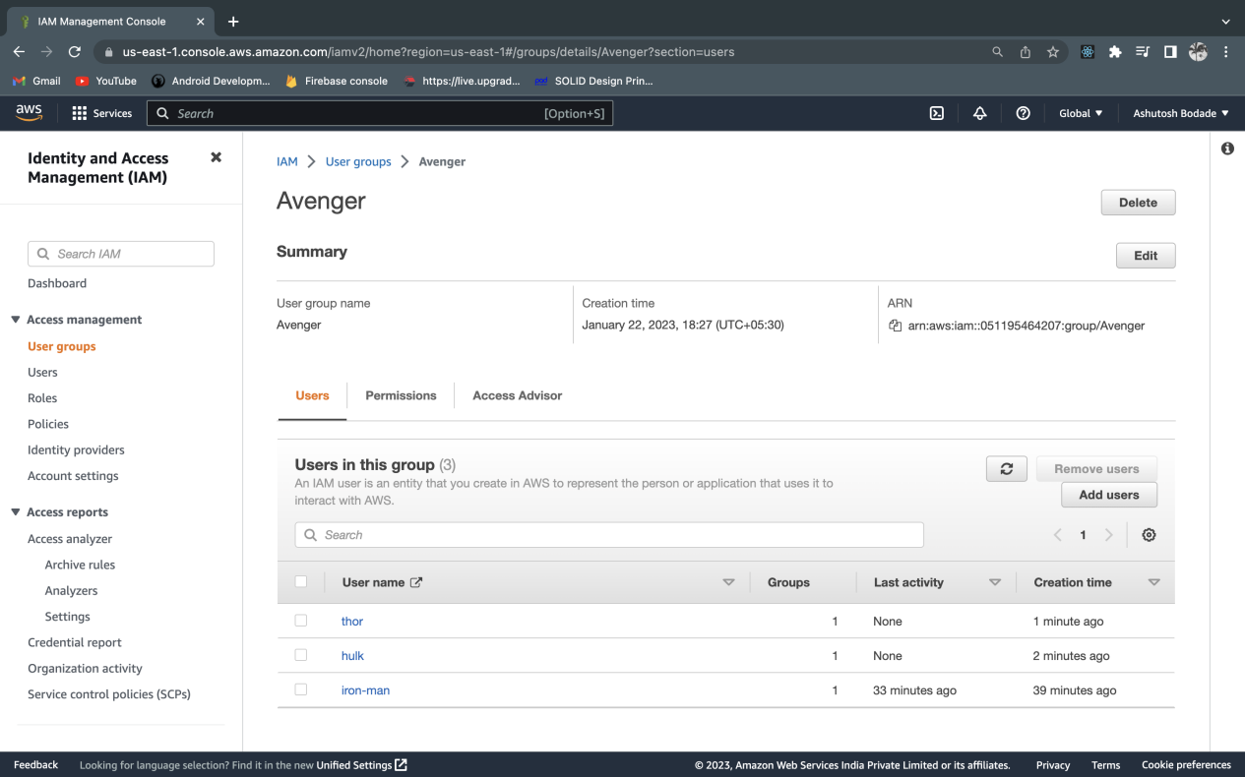

**Assignment 3** :- Define a condition in policy for expiration like

"DateGreaterThan": {"aws:CurrentTime":

"2020-04-01T00:00:00Z"},

"DateLessThan": {"aws:CurrentTime":

"2020-06-30T23:59:59Z"}

Define the span of 4 months as per your wish

Created policy which expires in 4 months with all access and assigned to user iron man

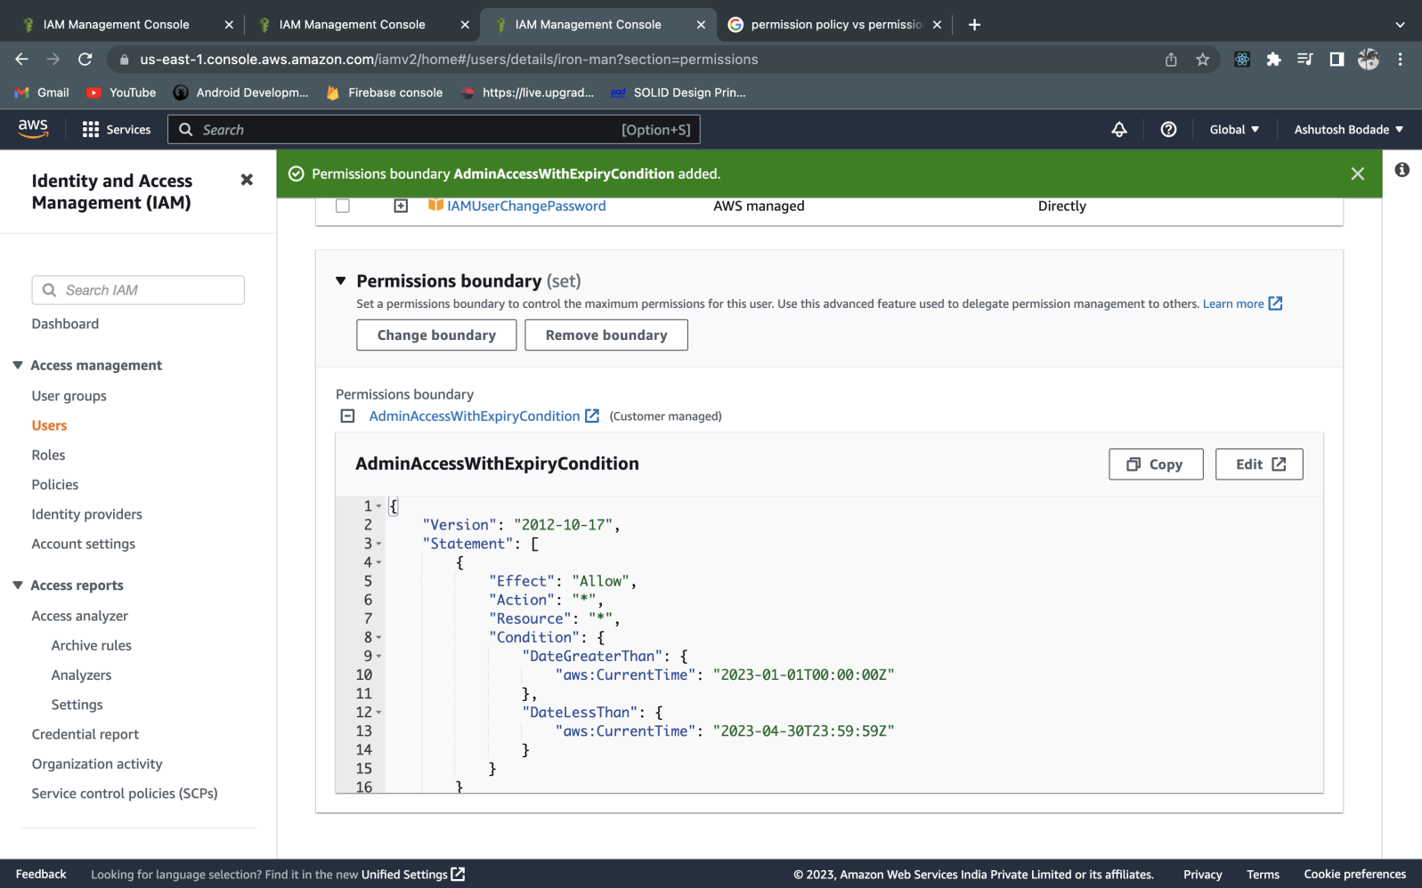

**Assignment 3** :- Prepare 15 authentic MCQ questions related to IAM.

**Assignment 4** :- Launch your linux instance in IAM and update your machine.

Created wc2 sysmet with amazon linux and updated it using sudo yum update

